Data Project Report

*John Hammersley*

# Design

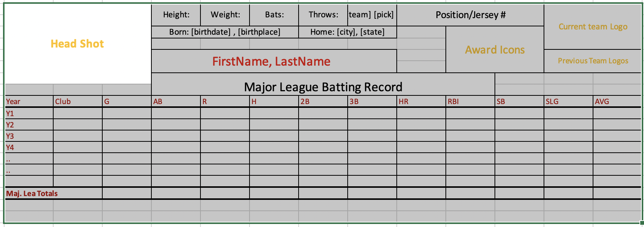

# Explanation

Growing up in the 80’s/90’s, I was a huge baseball card collector. I loved all of the cards of that time and I chose to design a card based off of cards from that time. I chose to make minimal changes to the stats that were on cards of that time. I wanted to include stats that you would see across multiple brands of cards, but also have some modern touches. The changes that I made from the cards of that time were to add the player headshot, team logo and awards icon section.

# Methodology

## Web Services

I started by looking at different baseball cards of the time, but in the end gravitated towards one of my favorite cards in my collection form that time. It is my Topps Ken Griffey Jr. rookie card. Once deciding on a card to model after, I sketched it out on paper several times trying to find the best way to place my additions on there. After sketching it out, I explored the STATS API json doc that you sent in your example to find what endpoints had the required information. I was able to get all of the required information via two API calls.

### People

The people endpoint really had the majority of what I needed relating to a player. The documentation doesn’t include much information about what the options are or what is included with each, so it took some time and testing to pull the data and then see what I was getting back and then figuring out the hydrations required (awards, education, stats), the most difficult part was parsing out the data. Unnesting the responses to get the data into a flat structure took some trial and error, and printing out at certain times to see what I was getting and then adjust accordingly.

### Draft

The draft endpoint did require the draft year and the personId to get back the data. So, in order to get this data, I had to make two api calls. The first call gets back the person info, which will give me the Draft year and personID that I can use to make another api call which I chose to store both the person data and draft data in one json object for parsing.

## Data Model

The data model is as follows:

**Person**: Contains the main player biographical data. This is the main records for the player. This table will have a one-to-many relationship with (stats,teams and awards)

**Stats**: Contains all the statistical info on the player for all teams that he has played for.

**Teams**: Contains information on each team that the player has played for. I chose to only load MLB team only.

**Awards**: This will be the players award info. When I started looking at the info returned from the endpoint call, I was seeing a bunch of awards that a player could have. Like player of the week, which I didn’t feel relevant to have on the card. Also, I didn’t want to pull every award the player ever got, because it could either crowd the card, or simply not fit. So, in the end I chose to just go with listing the Golden Glove Award. This section could also to be expanded to include other awards.

## Future Expansion on Code

Currently the code is hardcoded to a playerID. It could be adapted to pull info for multiple players and store them base on Team, Division or even League. It would take finding the endpoint that would return the information needed and then applying that to the code in an addional api call.

Another expansion I would do on this design would be to add more award info after researching and deciding what would be the best awards to list for the player.

I think one other final addition would be to add at least the college and minor league teams to the previous teams section.